**Organization structure**

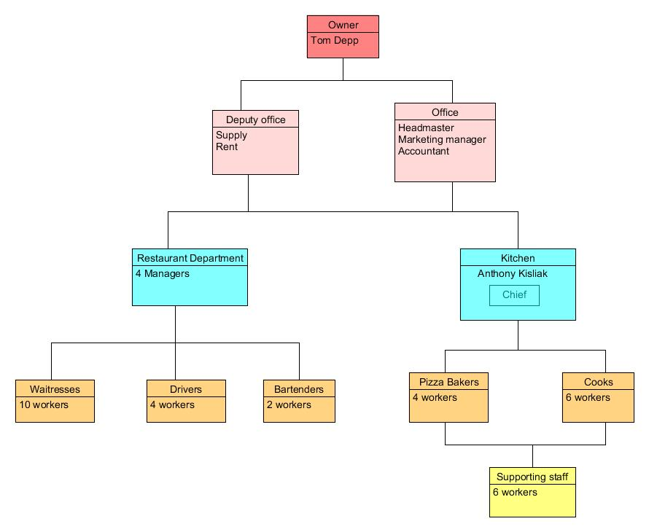

The company has 4 levels of hierarchy with the owner Tom Depp on top. Directly under him is offices with his oldest son as headmaster and his daughter as accountant. Deputy office has 2 employees, first one is Tom Depp’s wife who is responsible for supply for the whole restaurant. The second deputy is responsible for restaurant rent. This level of hierarchy is responsible for a kitchen and restaurant. Restaurant department has 4 managers who are in direct control of waitresses, drivers and bartenders. In the same level is Kitchen department with only one chief Anthony Kisliak who is in direct control of pizza bakers, cooks and supporting staff. While pizza bakers and cooks are also in control of supporting staff. As we see it is 4 levels of hierarchy, but the last one is the tiniest one. Overall this gives 42 employees and good clear structure.